Launch an EC2 instance (Linux and Windows) along with a web server. Then, create an EBS volume of 5 GB, attach it to an EC2 machine (Linux and Windows), and take a snapshot. Finally, create an EBS volume using the taken snapshot.

**Creating Linux EC2 Instance**

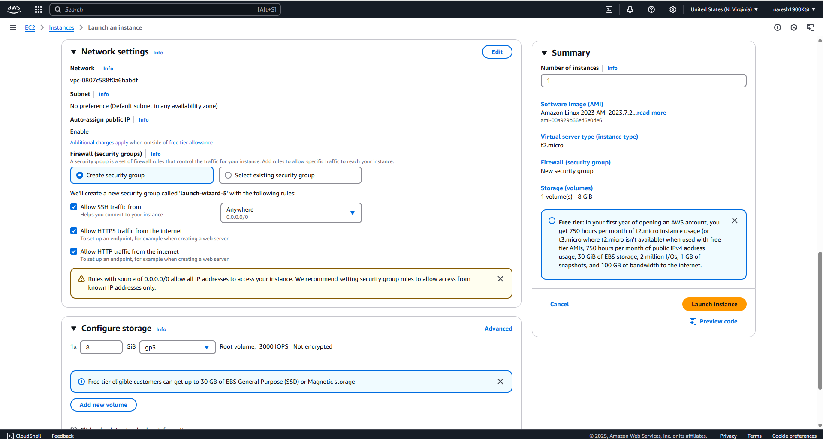

**EC2 Linux Instance Launched**

**Installing Web Server in Linux Machine**

**Windows Instance Creation**

**Web server installation in Windows**

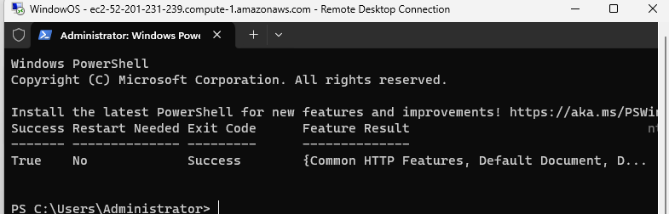

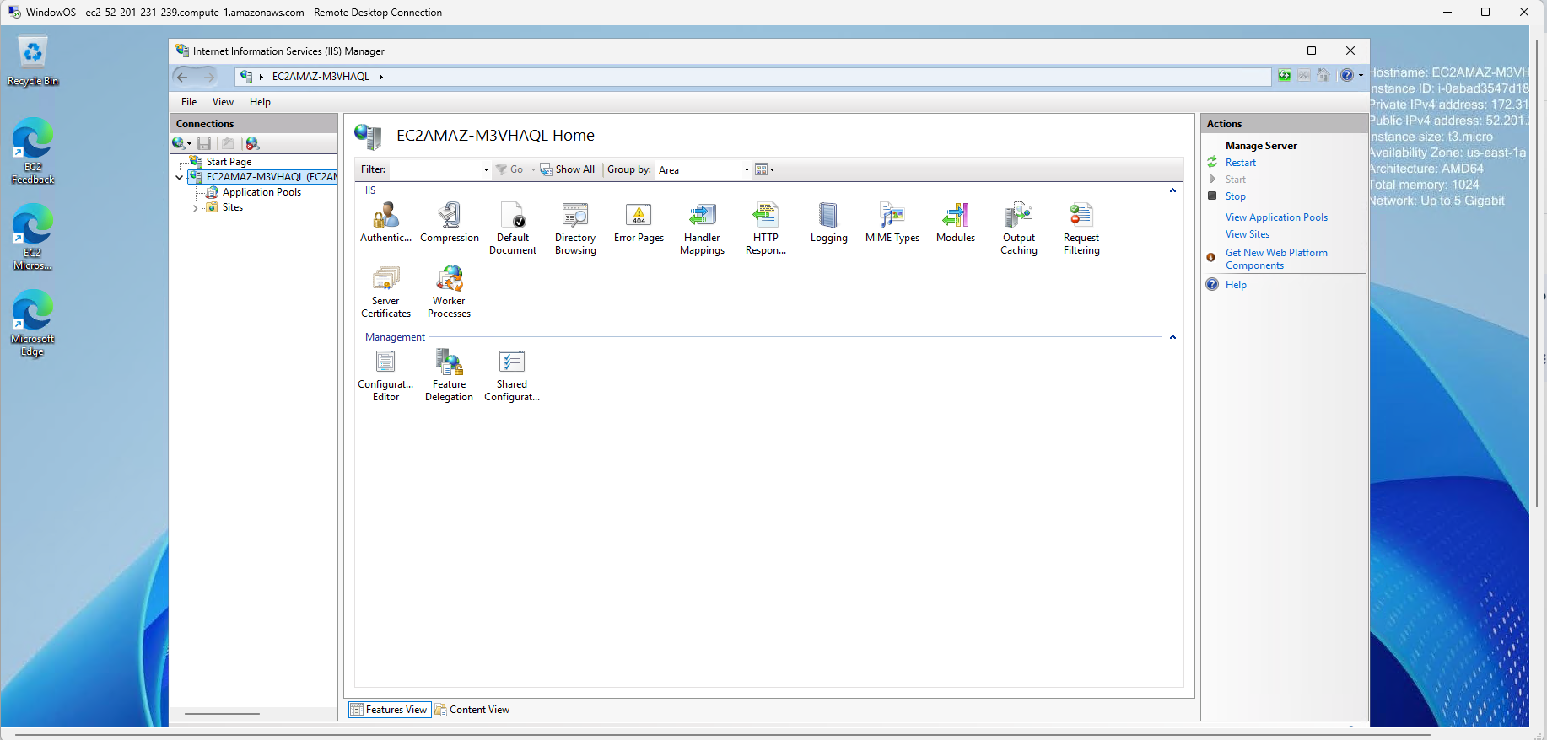

**Create EBS Volume - In the EC2 Dashboard, click on “Volumes” under “Elastic Block Store”.**

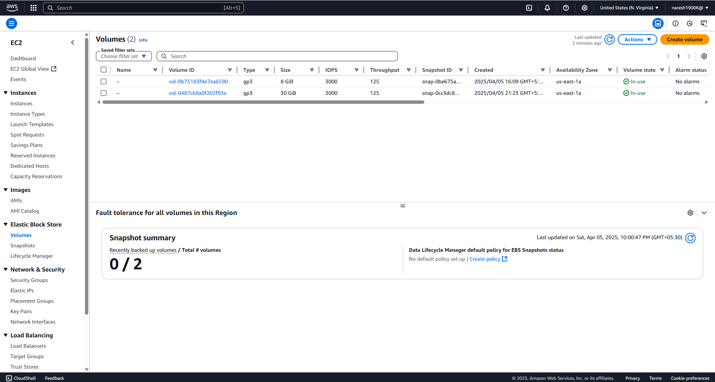

**Create Volume and attach it to the Windows Machine**

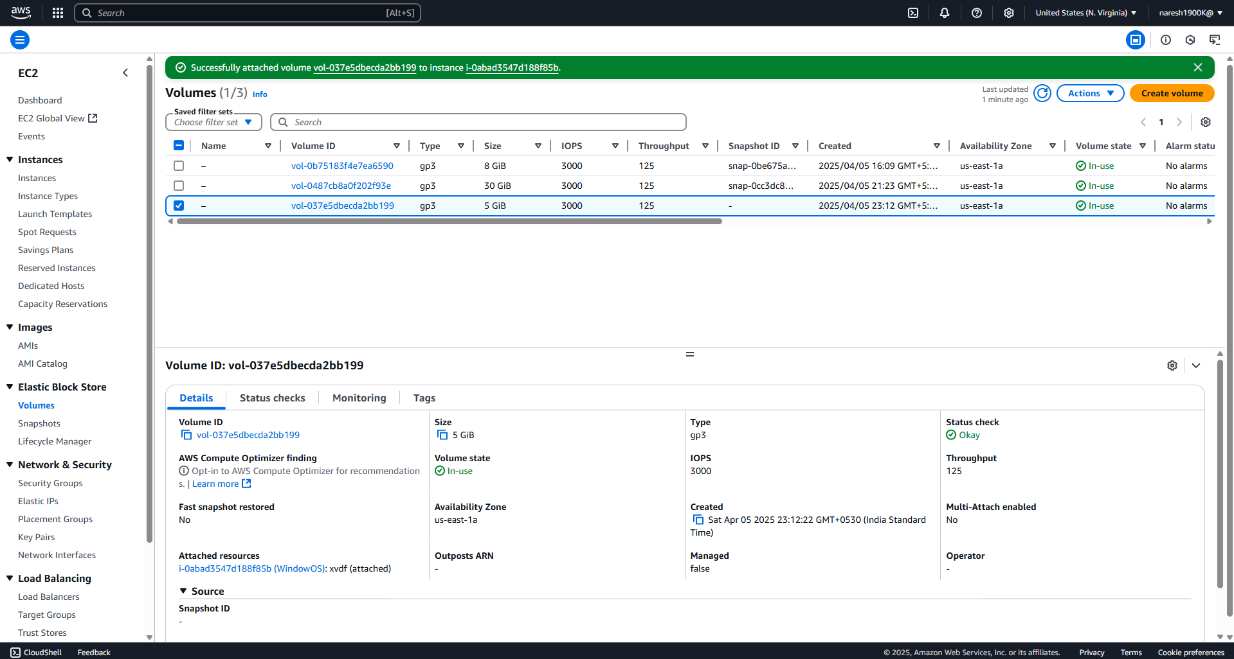

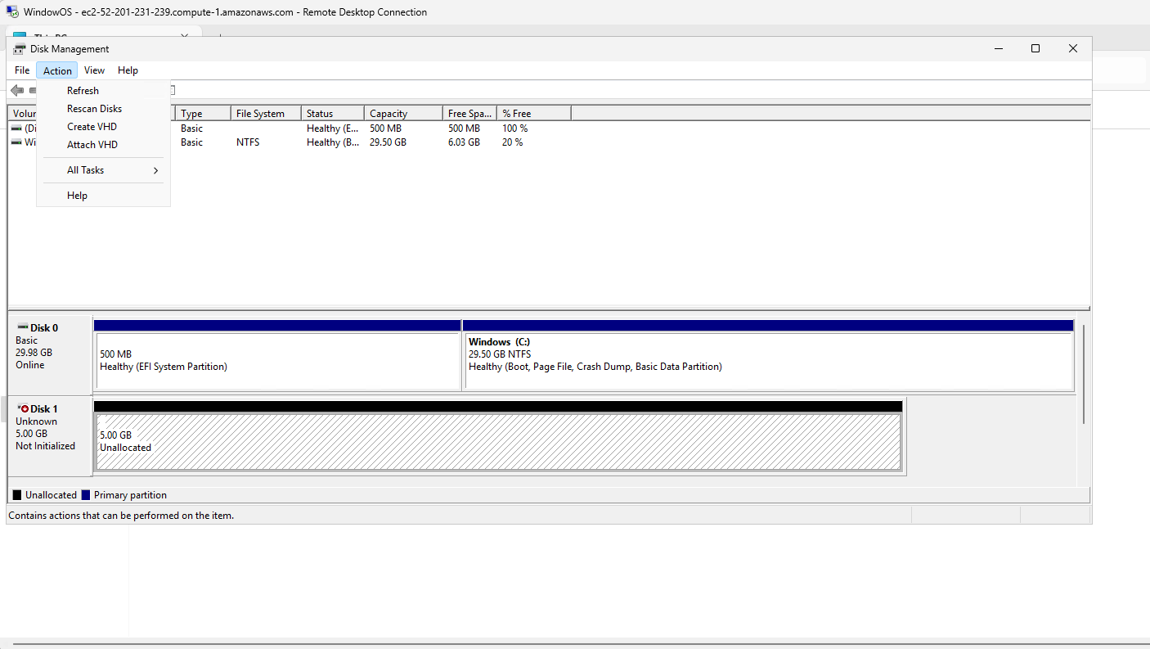

**Create Volume and attach it to the Linux Machine**

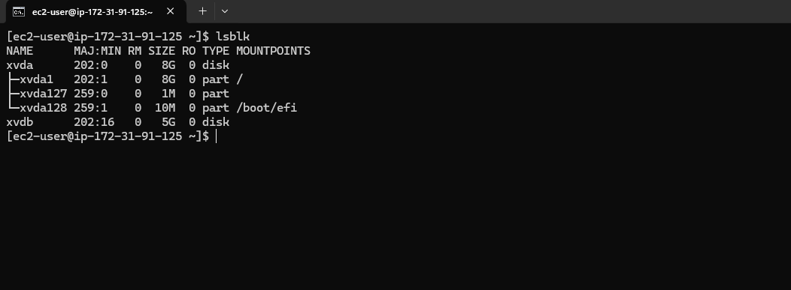

**Creating Snapshot for Linux**

**Creating Snapshot for Windows**

**Create an EBS volume using the taken snapshot.**

**Linux Volume creation through Snapshot**

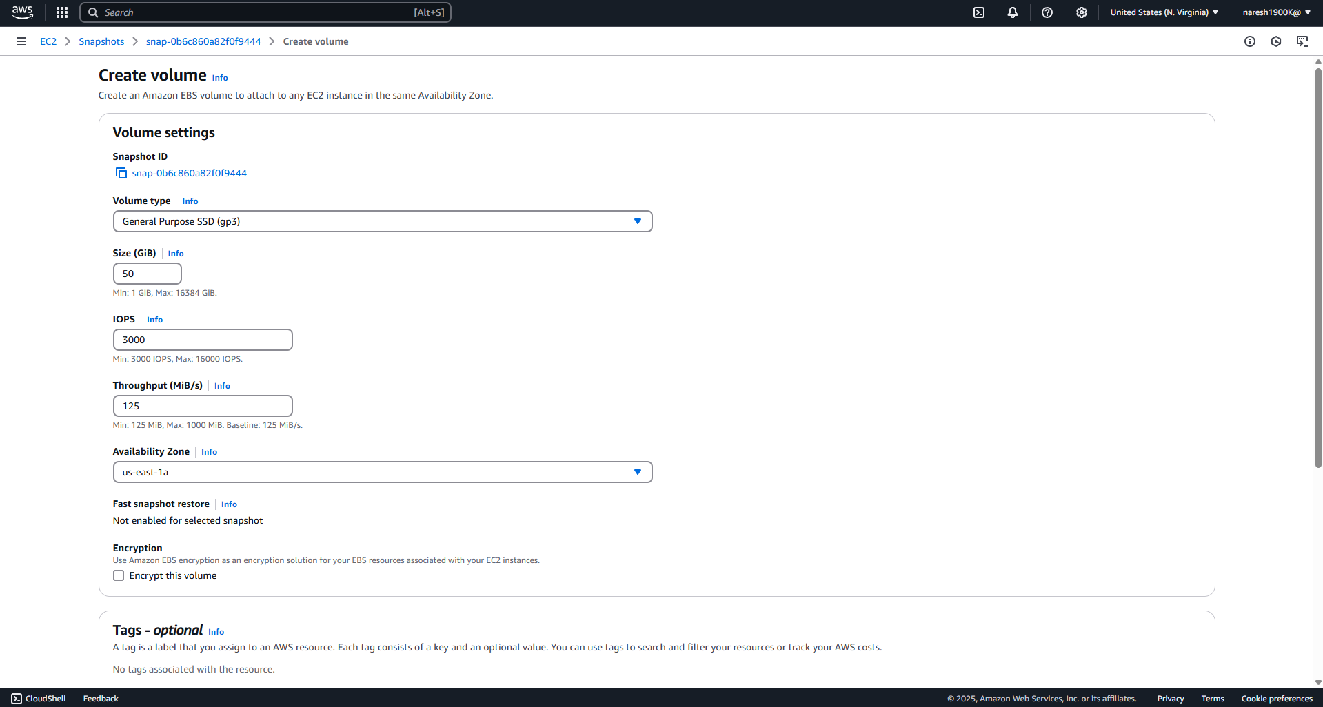

**Windows Volume creation through Snapshot**

